

**NATIONAL ECONOMIC CONSULTATIVE FORUM**

**MONTHLY ECONOMIC BULLETIN**

**MAY 2024**

# Executive Summary

This bulletin focuses on economic developments for the month ending 31 May 2024 that include Zimbabwe Gross Domestic Product (GDP) growth updates, merchandise trade developments, exchange rate developments, inflation developments, monetary developments and stock market developments as well as world economic developments and international commodity prices.

During the period under review, the global economy is expected to grow by 2.9% in 2024 slightly down from 3.1% in 2023, driven by resilient employment and income growth (Euromonitor International Second Quarter Global Economic Prospects 2024). In terms of outlook, global growth is expected to maintain 3.1% in 2025 as economic conditions normalize.

In May 2024, commodity prices maintained and upward trajectory from the previous month. Prices of natural gas, aluminium, copper, nickel, gold, soyabeans and wheat registered an increase while crude oil, cotton and corn registered a decline in May 2024.

By the time of compiling this report, the Zimbabwe National Statistical Agency (ZimStat) had not published the merchandise trade data for the month of May 2024, thus the analysis for merchandise trade remains unchanged from the April 2024 Economic Bulletin.

Meanwhile, the Zimbabwe Gold (ZiG) appreciated by 0.84% and 1.35% against the USD and ZAR respectively on a monthly basis, however ZiG depreciated by 0.63% against GBP and by 0.26% against the EUR. On Year-to-date (YtD) basis and Year-on-year (YoY) basis, the ZiG lost value against all major currencies.

Regarding cross rates developments, on a month-on-month (MoM) basis, the USD lost value against the GBP and EUR by 1.45% and 1.10%, respectively however, the USD appreciated against the ZAR by 0.50%.

In terms of inflation, during the period under review, the economy entered into a deflation mode with an inflation rate of -0.6% from 2.94% registered in April 2024. The sharp decline in monthly inflation reflects continues tight monetary stance taken by the Reserve Bank of Zimbabwe (RBZ) since the introduction of the new monetary policy measures on the 5th of April 2024. The main inflation drivers in the month of May 2024 are food and non-alcoholic beverages contributing a weight of 31.30 and housing, water, electricity, gas and other fuels with a weight of 27.62.

The RBZ had not yet published data on M3 and interest rates for May 2024 when the bulletin was compiled, thus the analysis remains unchanged from the April 2024 Economic Bulletin.

During the period under review, the Zimbabwe Stock Exchange (ZSE) recoded a bullish trend. The All-share index, Top 10 Index and Market Capitalization gained by 2.28%, 5.76% and 2.7%, respectively while the Value Traded declined by 62.56%. On the other hand, the Victoria Falls Stock Exchange (VFEX) registered a bearish trend. The market capitalization and the All-Share Index fell by 5.01% and 2.35%, respectively.

**Table of Contents**

Executive Summary i

1.0 World Economic Developments 1

1.1 World Growth Prospects 1

1.2 Global Inflation Developments 2

2.0 International Commodity Prices 2

3.0 Zimbabwe GDP Growth Update 3

4.0 Merchandise Trade Developments 3

5.0 Exchange Rate Developments 3

5.1 ZiG Exchange Rate Developments 3

5.2 Cross Rate Developments 3

6.0 Inflation Developments 4

7.0 Monetary Developments 5

7.1 Money Supply and Interest Rates 5

8.0 Stock Market Developments 5

8.1 Zimbabwe Stock Exchange 5

8.2 Victoria Falls Stock Exchange 6

9.0 Recommendations 6

10.0 References 8

**List of Tables**

Table 1: Commodity Price Movements – Month Ending 31 May 2024 2

Table 2: ZiG Exchange Rate Movements – Month Ending 31 May 2024 3

Table 3: USD Exchange Rate Movements – Month Ended 31 May 2024 4

Table 4: Monthly Inflation for May 2024 5

Table 5: Zimbabwe Stock Exchange Movements 6

Table 6: Victoria Falls Stock Exchange Movements 6

**List of Figures**

Figure 1: Global Economic Growth Developments 1

Figure 2: Month-on-Month Inflation Outturn 4

# 1.0 World Economic Developments

## **1.1 World Growth Prospects**

1.1.1 The global economy is expected to grow by 2.9% in 2024 slightly down from 3.1% in 2023, driven by resilient employment and income growth (Euromonitor International Global Economic, Second Quarter 2024). In terms of outlook, global growth is expected to maintain 3.1% in 2025 as economic conditions normalize. These forecasts slightly differ from the IMF World Economic Outlook April 2024 projections (see Figure 1).

Figure 1: Global Economic Growth Developments

*Euromonitor International 2024 Q2 Global Economic Forecasts and IMF WEO April 2024 Report*

1.1.2 According to the Euromonitor International 2024 Q2 Global Economic Forecasts, major economies are stabilising. The US economy has shown resilience in the first quarter of 2024, leading to an upgraded real GDP growth forecast of 2.1% for 2024, despite ongoing challenges including high interest rates, inflation, and consumer debt. Elsewhere, the Eurozone's growth is expected to remain low in 2024 at 0.7%, while China's growth forecast has been revised upward to 4.7% in 2024, driven by stronger investments, but still faces restraints from a lingering real estate crisis and subdued private consumption.

1.1.3 A steady growth in developing and rising economies is expected, with minor regional disparities. Emerging and developing economies are expected to outperform advanced economies in 2024, with a real GDP growth rate of 4.0% compared to 1.4% in advanced economies, led by strong growth in emerging Asian countries such as India, Indonesia, Vietnam, and the Philippines. However, growth will be subdued in some Latin American markets, including Mexico and Brazil, due to softening domestic and external demand, fiscal consolidation, and tight monetary policy.

## **1.2 Global Inflation Developments**

1.2.1 Global inflation forecasts remain unchanged. According to the IMF World Economic Outlook April 2024 projections, global inflation stood at 6.8% in 2023 and projected to fall to 5.9% and 4.5% in 2024 and 2025 respectively. *The downward trend in global inflation developments points towards accommodative interest rates which is a boon for Zimbabwe.*

## **2.0 International Commodity Prices**

2.1 During the month under review, commodity prices registered an upward trend. This was mostly due to geopolitical conflicts such as the Russia-Ukraine conflict, the Gaza war, El Nino-induced drought which interrupted transit routes and led to shortages hence increased prices. Prices of natural gas, aluminium, copper, nickel, gold, soyabeans and wheat registered an increase while crude oil, cotton and corn registered a decline (see Table 2).

2.2 On a year-to-date basis (YtD) and year-on-year (YoY) basis, crude oil, natural gas, aluminium, copper and gold prices gained while nickel gained on a YtD basis and lost on a YoY basis.

2.3 On agricultural commodities, cotton lost by 10.63% and 8.82% on YtD and YoY, respectively, and corn also lost by 2.67% on YtD and 13.56% on YoY. Soyabeans also lost by 2.28% and 1.08% on a YtD and YoY basis, respectively while wheat gained on both YtD and YoY. Cotton, corn and soyabeans prices prospects are discouraging for the country’s agricultural sector growth while, wheat price movements are encouraging.

Table 1: Commodity Price Movements – Month Ending 31 May 2024

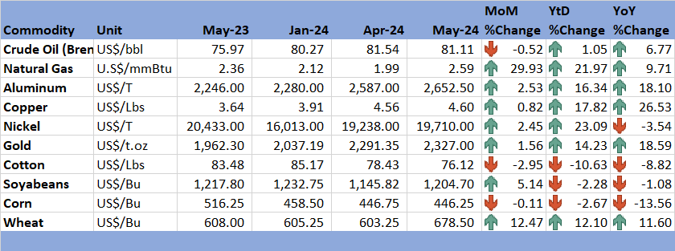

*Source: Trading Economics (2024)*

# 3.0 Zimbabwe GDP Growth Update

3.1 The country’s GDP growth rate remain projected at 3.5% in 2024, higher than the IMF's WEO April 2024 update projection of 3.2%. The country’s growth rate in 2024 is expected to be lower than 2023 growth due to the effects of the El Nino induced drought, the impact of structural bottlenecks, and lower agricultural commodity prices. El-Nino-induced drought affected most rain-fed crops, intensify electricity supply shortages and allocation of resources to ensure food security rather channelling them to productive sectors.

# 4.0 Merchandise Trade Developments

4.1 By the time of compiling this report, the Zimbabwe National Statistical Agency (ZimStat) had not published the merchandise trade data for the month of May 2024, thus the analysis for merchandise trade remains unchanged from the April 2024 Economic Bulletin.

# 5.0 Exchange Rate Developments

## **5.1 ZiG Exchange Rate Developments**

5.1.1 The Zimbabwe Gold (ZiG) appreciated by 0.84% and 1.35% against the USD and ZAR respectively on a monthly basis, however the ZiG depreciated by 0.63% against GBP and by 0.26 against the EUR. On Year-to-date and Year-on-year basis the ZiG lost value against all major currencies as shown by Table 2.

Table 2: ZiG Exchange Rate Movements – Month Ending 31 May 2024

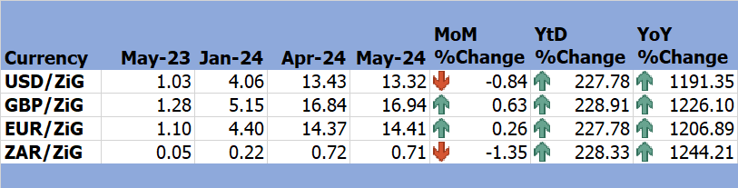

*Source: RBZ (2024)*

## **5.2 Cross Rate Developments**

5.2.1 On MoM basis, the USD lost value against the GBP and EUR by 1.45% and 1.10% respectively however, the USD appreciated against the ZAR by 0.50% as shown in Table 3. *If the appreciation of the USD (one of the major currencies used in Zimbabwe) is sustained, it makes products from Zimbabwe’s major trading partner (South Africa) cheaper promoting importation of capital goods encouraging local production. However, this comes with adverse spillover effects such as imported inflation, which tend to discourage local production, worsens the trade deficit and increases loss of foreign reserves in the economy which further compromises the exchange rate.*

Table 3: USD Exchange Rate Movements – Month Ended 31 May 2024

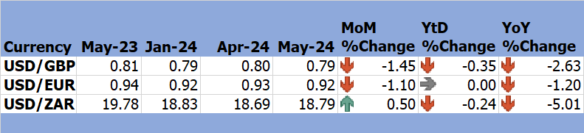

*Source: RBZ (2024)*

5.2.2 Meanwhile, the USD and the EUR remained at par on a YtD basis and lost on a YoY basis. The USD lost against GBP, and ZAR on both YtD and YoY basis. *The trend of the ZAR on a YtD and YoY basis promotes competitiveness of Zimbabwean goods in the South African market promoting exports and local production.*

# 6.0 Inflation Developments

6.1 During the period under consideration, the economy entered into a deflation mode. Inflation declined to -0.6% from 2.94% recorded in April 2024 (see Figure 2). The sharp decline in monthly inflation reflects a continues tight monetary stance taken by the Reserve Bank of Zimbabwe (RBZ) since the introduction of the new monetary policy measures on the 5th of April 2024.

6.2 The main drivers of inflation in May 2024 are food and non-alcoholic beverages contributing a weight of 31.30 and housing, water, electricity, gas and other fuels with a weight of 27.62 (see Table 4).

Figure 2: Month-on-Month Inflation Outturn

*Source: ZimStat (2024)*

6.5 Table 4 displays the key contributors to inflation in May 2024.

Table 4: Monthly Inflation for May 2024

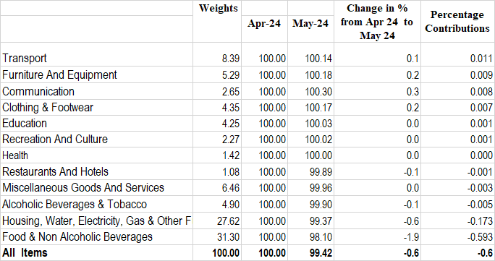

*Source: ZimStat (2024)*

# Monetary Developments

## **7.1 Money Supply and Interest Rates**

7.1.1 The RBZ had not yet published data on M3 and interest rates for May 2024 when the Bulletin was compiled, thus the analysis remains unchanged from the April 2024 Economic Bulletin.

# 8.0 Stock Market Developments

## **8.1 Zimbabwe Stock Exchange**

8.1.1 During the period under review, the Zimbabwe Stock Exchange (ZSE) recoded a bullish trend. The All-share index, Top 10 Index and market capitalization gained by 2.28%, 5.76% and 2.7% respectively while the Value Traded declined by 62.56%.

8.1.2 The All Share Index fell by 52.9% and rose by 133.42% on Ytd and YoY basis respectively. On the other hand, the Top 10 Index grew by 5.35% on Ytd and 288.27% on YoY basis while Value Traded fell by 97.38% and 77.45% on Ytd and YoY basis respectively (see Table 5).

Table 5: Zimbabwe Stock Exchange Movements

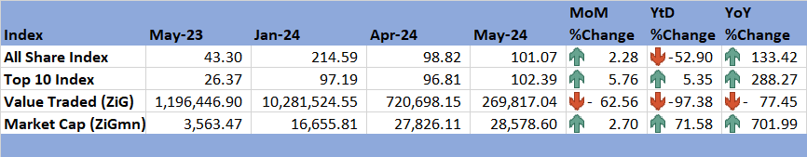

*Source: ZSE (2024)*

8.1.3 Market Capitalisation in May 2024 stood at ZiG28578.6 million reflecting a 2.7% increase from the ZiG27826.11 million in April 2024. On a YtD and YoY basis, market capitalization added 71.58% and 701.99%, respectively as shown in Table 5.

## **8.2 Victoria Falls Stock Exchange**

8.2.1 In May 2024, the Victoria Falls Stock Exchange (VFEX) registered a bearish trend. On a MoM basis, market capitalization and the All-Share Index fell by 5.01% and 2.35% respectively. Meanwhile, Valued Traded increased by 7031.42%, as indicated in Table 6.

8.2.3 On YtD basis, the All-Share Index and Market capitalisation fell by 5.12% and 7.91%, respectively, while Value traded rose by 43.98%. Regarding YoY basis, the All-Share Index and value traded grew by 18.72% and 627.69%, respectively. However, market capitalization dropped by 19.73%.

Table 6: Victoria Falls Stock Exchange Movements

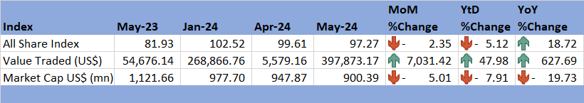

*Source: VFEX (2024)*

# 9.0 Recommendations

* 1. The following recommendations are being proposed:

9.1.1 **Strengthen Trade Relations**: The country should enhance trade partnerships with emerging Asian economies (India, Indonesia, Vietnam, and the Philippines) expected to experience higher growth. This can help diversify export markets and reduce dependency on traditional markets.

* + 1. **Diversify Economy**: There is need to invest in sectors other than agriculture, such as manufacturing and services, to reduce vulnerability to climate-induced disruptions like the El Niño drought.
    2. **Fiscal Stimulus**: There is need to consider targeted fiscal stimulus to support sectors hit hard by the drought and other structural bottlenecks. This could include subsidies for affected farmers and investments in drought-resistant crops and irrigation infrastructure.
    3. **Commodity Reserves**: The country should establish strategic reserves for key commodities like wheat to mitigate the impact of price volatility and ensure food security.
    4. **Subsidies for Agriculture**: There is need to provide subsidies and financial support to farmers growing crops that have shown price resilience (e.g., wheat) and those facing price declines (e.g., cotton, soybeans) to stabilize the agricultural sector.
    5. **Enhance Value Addition**: Zimbabwe is a primary products-based economy and mostly exports low priced raw products. The country needs to improve value addition and strategies to move production processes up the value chain. This may be achieved through adoption of advanced technologies and establishment of processing plants to promote high-valued exports and at the same time reducing imports since the previously imported products will be produced locally (Import substitution). Through value addition, the economy can benefit from rising international commodity prices of minerals (copper, nickel, aluminium and gold) by exporting processed high-valued product rather than low-valued raw products, at the same time exploiting a fall in agricultural commodity prices through using those low-priced raw materials (cotton, corn and soyabeans to produce high-valued commodities.
    6. **Stabilize the Currency**: The ZiG gained some momentum (appreciated against USD and ZAR) but lost value against GBP and EUR. Thus, there is need for continued efforts to stabilize the Zimbabwe Gold (ZiG) currency through prudent monetary policies and by building foreign exchange reserves. The RBZ should engage with international financial institutions for technical assistance and best practices.
    7. **Monitor Inflation Drivers**: There is need to closely monitor inflation drivers, particularly food and non-alcoholic beverages, and housing costs.
    8. **Promote Stock Market Participation**: There is need to encourage broader participation in the ZSE and VFEX by promoting financial literacy and investor confidence.

# 10.0 References

Euromonitor International. (2024, April). *Global Economic Forecasts: Q2 2024*. Retrieved from Euromonitor International: https://www.euromonitor.com/global-economic-forecasts-q2-2024/report?utm_source=RE-GEF-2024-mid-year&utm_medium=foleon&utm_campaign=CT_24_RE_GEF_2024_Outlook_Mid-Year

IMF. (2024). *World Economic Outlook Update, April 2024.* International Monetary Fund.

MOFEDIP. (2023). *The 2024 National Budget Statement.* Ministry of Finance, Economic Development and Investment Promotion.

RBZ. (2024). *2024 Monetary Policy Statement.* Reserve Bank of Zimbabwe.

RBZ. (2024). *Exchange Rates*. Retrieved from Reserve Bank of Zimbabwe: https://www.rbz.co.zw/index.php/research/markets/exchange-rates

Trading Economics. (2024). *Commodities*. Retrieved from Trading Economics: https://tradingeconomics.com/commodities

VFEX. (2024). *VFEX Main Dashboard* . Retrieved from Victoria Falls Stock Exchange: https://www.vfex.exchange/

ZimStat. (2024). *Inflation Rates*. Retrieved from Zimbabwe National Statistical Agency: https://www.zimstat.co.zw/

ZimStat. (2024). *Merchandise Trade Statisitics* . Retrieved from Zimbabwe National Statistical Agency: https://www.zimstat.co.zw/

ZSE. (2024). *ZSE Main Dashboard*. Retrieved from Zimbabwe Stock Exchange: https://www.zse.co.zw/

**NECF Secretariat, 2024**